1. Objective
The objective of this exercise was to understand Nmap live host discovery and learn how to identify active hosts on a network.
2. Concepts Learned
- Live host discovery
- Identifying active devices on a network
- ICMP echo requests and replies
- ARP-based host discovery
- TCP and UDP probes
- Nmap host discovery options
- The importance of host discovery in network security monitoring
3. Tasks Performed
- Studied the purpose of Nmap live host discovery.
- Learned how Nmap checks whether a target host is online.
- Reviewed different host discovery techniques using ICMP, ARP, TCP, and UDP probes.
- Learned how to use Nmap commands to discover live hosts.
- Reviewed how host discovery helps security professionals understand which systems are active on a network.
4. Commands Used
Command 1:
nmap -sn <target-ip>
Explanation: Performs host discovery without conducting a port scan.
Command 2:
nmap -sn <network-range>
Explanation: Checks for live hosts across the specified network range without scanning ports.
Command 3:
nmap -sn -PR <target-ip>
Explanation: Uses ARP requests for host discovery on a directly connected Ethernet network.
Command 4:
nmap -sn -PE <target-ip>
Explanation: Uses ICMP echo requests to check whether the target responds.
5. Findings and Observations
- Live host discovery helps identify devices that appear to be online.
- Nmap can use multiple techniques to determine whether a host is reachable.
- Firewalls may block discovery probes, so an active host can sometimes appear unavailable.
- ARP discovery is useful on local Ethernet networks.
- Host discovery helps administrators maintain network visibility and identify unexpected devices.
- SOC Analysts can use host discovery knowledge when investigating network activity and identifying potentially unauthorized systems.
6. Screenshot
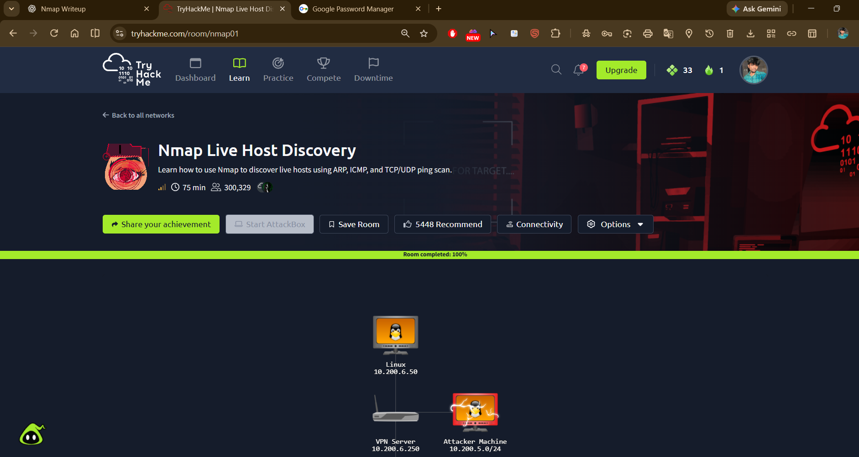Caption: Completed the Nmap Live Host Discovery exercise and reviewed techniques for identifying active hosts on a network.
7. Challenges Faced
The main learning challenge was understanding the differences between ICMP, ARP, TCP, and UDP host discovery techniques and when each technique may be useful.
8. Conclusion
This exercise helped me understand Nmap live host discovery and the techniques used to identify active hosts on a network. These concepts are important for network reconnaissance, asset visibility, and SOC monitoring.

